**Divesting Harvard’s Endowment**

**Muhammad Nidal Khan**

**30071473**

**FNCE 559 – 01**

**Stephanie Kristensen**

**Introduction:** Recently Harvard endowment has been increasingly more scrutinized to incorporate ESG considerations into its investment strategies. The two issues concerning Harvard Management Corporation (HMC) were the new strategy’s effects on the endowment’s financial returns and the harmony between its objectives and universal ideals. In this memo, I’ll cover the issues regarding increasing social pressure on HMC investment strategies, the impacts that come with Harvard’s failure to address concerns of employees and students, and HMC’s full divestment from fossil fuels.

**Background:** “The perceived international position of Harvard University places the university directly in a position of leadership” (Green et al., 2020) In 2018, 71% of Harvard university students favoured divesting from investments in fossil fuels. Many university endowments have started to shift their investments away from fossil fuels and towards more environmentally friendly alternatives, often as a result of social pressure. However, the university has made it quite clear that HMC will continue to be an unbiased investor and will not utilise its investment strategy to further any political objective. Complete divestment could be an option for Harvard but, it's very possible that HMC’s actions wouldn’t have any positive effects on climate change and might even lower the school’s annual returns. The main objective still stands, which is to answer the question of whether Harvard has a moral obligation to combat climate change through its investment strategies.

**Evaluation:** **What’s working?** The sustainable investing policy of HMC is the first of Harvard’s advantages in terms of ESG. In order to ensure that best ESG investing practices are being followed, the policy outlines commitment to ESG integration techniques, an active ownership investment style, and partnership with other sustainable investors. HMC is a proactive leader in the ESG investment field as evidenced by the fact that it was the first endowment to join the United Nations Principles for Responsible Investment. Active ownership is another strength of Harvard. Harvard has two committees (ACSR & CCST) composed of many different Harvard stakeholders including alumni, faculty, and students who provide advice on voting in accordance with environmental concerns. The incorporation of these committees presents Harvard as a University with a mission that is driven towards advocating positive change in terms of ESG concerns. Lastly, regarding quantifiable outcomes, the university said that its operations would be fossil fuel net neutral by 2026, and fossil fuel free by 2050 (Green et al., 2020). **What’s not working?** Harvard’s failure to address the concerns of its faculty, alumni, and students is the result of inadequately dealing with issues relating to ESG specifically, the divestment from fossil fuels. The formation of Divest Harvard (DH) society by students is evidence that Harvard, although it is progressing, is still not taking the necessary steps required to eliminate the use of fossil fuels. The DH society sued Harvard between 2012 and 2017 for breaching its fiduciary duties. This harms Harvard's reputation by demonstrating that existing students are dissatisfied with the institution, which will discourage prospective students from attending. The ability of Harvard to keep its employees could develop into a weakness that needs to be addressed by Harvard. Since 67% of the Harvard faculty backed students on divestment, the DH movement enjoyed widespread support. Harvard can become the target of problems relating to employee retention as a result of disregarding constant movements by students and faculty to divest from the use of fossil fuels. Lastly, the most important problem identified in the case was the overwhelming social pressure by various stakeholders who had opposing views, that HMC was a target of in terms of their investing strategies. In some instances, HMC reports what people want to hear rather than face criticism for its actions. Such was the case when the university claimed they cannot fully divest from fossil fuels due to the enormous investments in things such as mutual funds and commingled funds.

**Solutions:** One benefit whereby HSB can incorporate ESG considerations into its investment portfolio, is by completely divesting from fossil fuels. As we have established, the university is facing increasing social pressure from its stakeholders on integrating ESG issues into the investment framework. Natural resources are the least profitable part of Harvard's endowment, and they are also quite dangerous over the long term. As seen in Exhibit A, the S&P ESG index and the S&P oil and gas industry index both started at the same point. However, by 2019 the S&P ESG index reached over 300 and the S&P oil and gas industry index was only a little above 50. Furthermore, Exhibit B shows the enormous amounts of direct emission from utilities and Energy industries with the relevant market caps being very small compared to other industries. This represents a significant shift which is the decrease in value of utilities and energy companies so, by choosing to divest from these companies the university would not only benefit in terms of helping the climate, but also financially. It is also important to note that investors are being forced by the climate crisis to look beyond the short term and realise that there are no profits in a dead world (Green et al., 2020). HSB can also benefit from developing a criterion by which the university can value which companies should be part of the broader portfolio similar to what NBIM did with their ethical and risk-based divestments in Exhibit C. This will allow them to focus on the most important theme and incorporate important stakeholders inputs on the selected criterion. Another change the university could implement is using active or direct engagement with companies on issues relating to the use of fossil fuels.

**Recommendation:** First recommendation would be for HSB to come up with an employee engagement program in addition to creating a criterion, by which they can decide which companies to divest from. Considering how strongly committed the faculty and students are towards driving ESG goals, HSB can benefit greatly by giving these individuals a voice in board meetings and shares in stocks. Harvard can use this criterion with faculty and students to help in developing an acceptable partial divestment strategy that would be in accordance with most stakeholder views. Another recommendation for Harvard would be to completely divest from companies that use fossil fuels. Harvard’s university endowment was the largest in 2020 placing the university in the role of a leader. As shown in Exhibit D, by 2020, many universities have tried partial divestment, with University of California being the only one who has fully divested from the use of fossil fuels. Although, University of California gained widespread attention, many other institutions were skeptical about the financial implications this could have. As previously discussed, there is already a significant downwards shift in the value of energy and utilities companies. Harvard would undoubtedly experience financial losses if it totally divested from businesses that depend on fossil fuels. However, by making investments in a variety of sectors with significant market capitalization, such as information technology or healthcare shown in Exhibit B, they would be able to recover the losses. Although Harvard can’t completely impact climate change by adopting full divestment by itself, it will lead to a systematic change in all universities thereby, creating a drastic change in the climate change sector.

**Conclusion:** In conclusion, HSB has been inadequately tackling concerns regarding ESG issues specifically being fossil fuels. One solution that can resolve this issue is through the creation of specific criteria by which companies can be divested ultimately targeting reduction in fossil fuels completely. However, the most beneficial and recommended action plan for Harvard would be the full divestment from fossil fuels. Whereby, the institutional leader Harvard would start off a drastic change in the Climate sector incentivising other smaller institutions to follow in its footsteps.

**References**

Green, D. & Viceira, L. M. Fetter, H. (October, 2020) *"Divesting Harvard’s Endowment" Harvard Business School Case 221-009,* Retrieved February 10, 2023, from <https://www.hbs.edu/faculty/Pages/item.aspx?num=58913>

**Exhibits**

*Exhibit A*

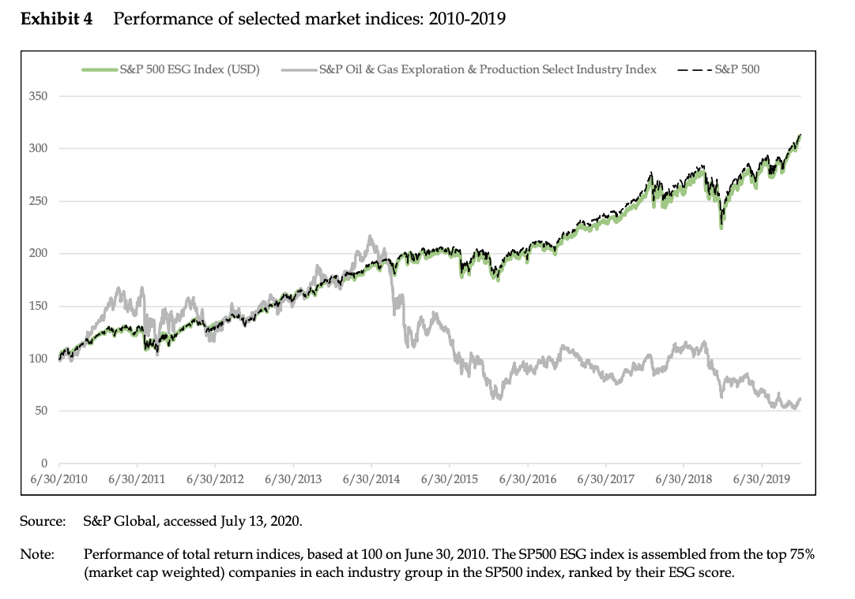

*Exhibit B*

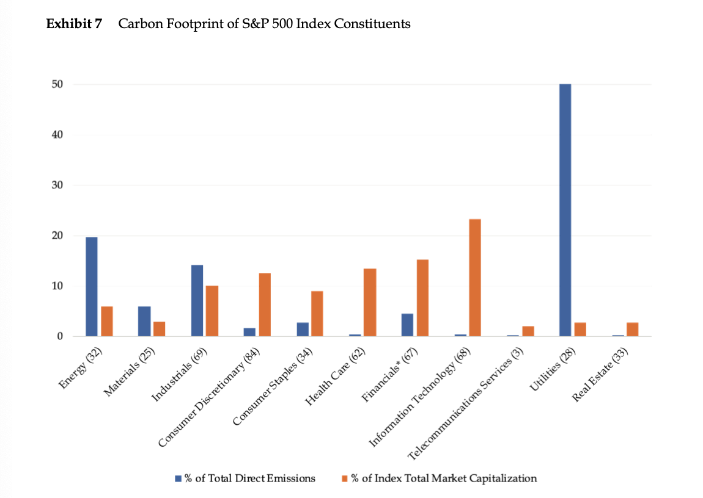

*Exhibit C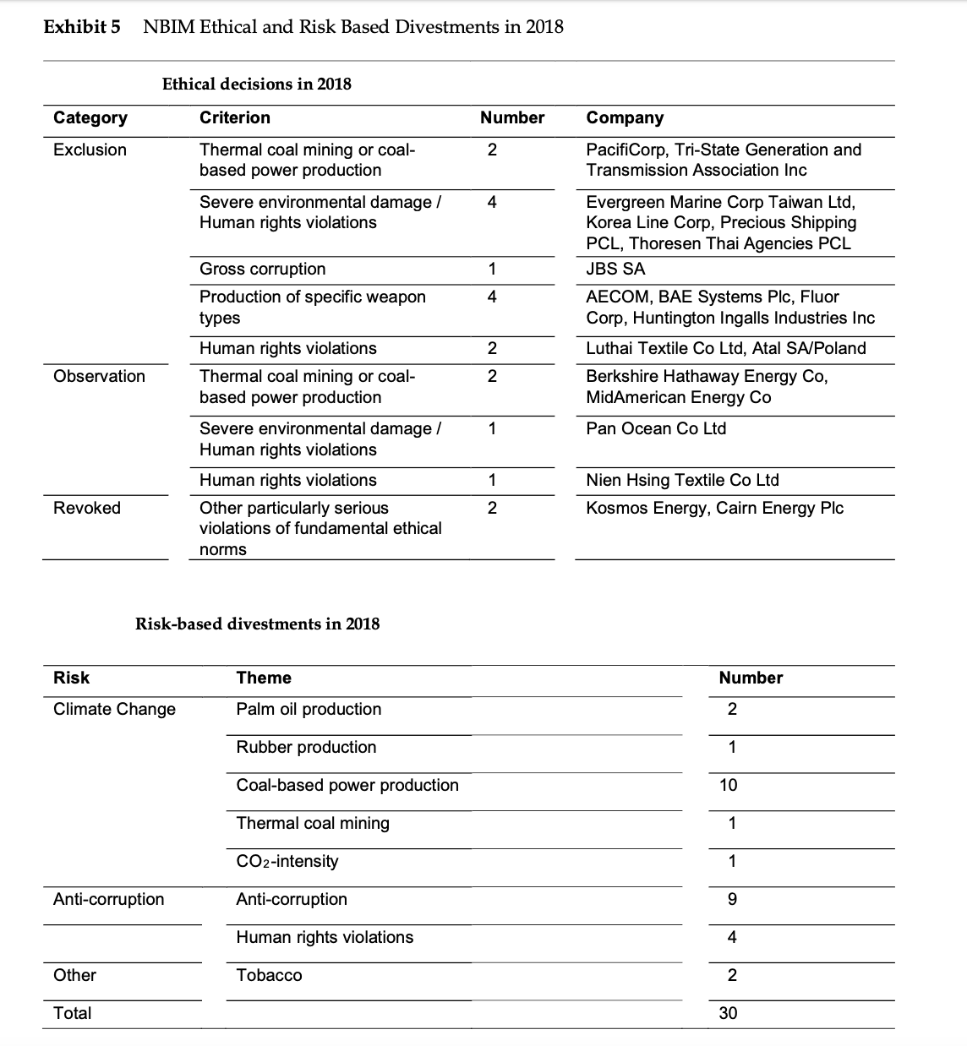*

*Exhibit D